Infosys Springboard Virtual Internship 6.0 Completion Report

# Team Details <Do not mention any personally identifiable information like email ID, institute details, mobile phone number etc.>

Batch Number : 4

Start date : 13 October 2025

Name: Sontanam V C M Bhavani Sundari

Internship Duration: 8 Weeks

# Project Title

NeuroFleetX AI-Driven Urban Mobility Optimization.

# 2. Project Objective The goal of the NeuroFleetX project was to build a smart system to manage rides, drivers, and vehicles efficiently. It helps automatically assign drivers, track rides in real-time, and monitor vehicle health. The system reduces delays and ensures smooth operations. Overall, it improves customer experience and makes the organization more efficient.

# 3. Project description in detail NeuroFleetX is an AI-driven urban mobility platform that optimizes ride booking, driver assignment, and vehicle management. Built with Spring Boot, MySQL, and JWT security, it provides real-time ride tracking, automated driver allocation, and vehicle health monitoring. The system includes an admin dashboard for efficient fleet management. It enhances operational efficiency, ensures vehicle safety, and improves customer experience in urban transportation.4. Timeline Overview

|  |  |  |
| --- | --- | --- |
| Week | Activities Planned | Activities Completed |
| Week 1 | plan to start learning basic React concepts. complete practice exercises for Java,React. | Completed as planned |
| Week 2 | Plan to learn Spring Boot basics | Completed as planned |
| Week 3 | develop backend for login page using Spring Boot. | Completed as planned |
| Week 4 | Plan to work on the Vehicle Booking feature | Completed as planned |
| Week 5 | start feedback form integration. | Completed as planned |
| Week 6 | Planned to work on implementing the ”Manage users” feature in the Admin Dashboard | Completed as planned |
| Week 7 | Planned to implement ride-related features in the customer dashboard, including canceling rides, viewing ride statistics, and searching past rides | Completed as planned |
| Week 8 | Planned to work on admin-related modules such as handling customer complaints and viewing dashboard analytics | Completed as planned |

# 5a. Key Milestones

|  |  |  |
| --- | --- | --- |
| Milestone | Description | Date Achieved |
| Project Kickoff | Started the NeuroFleetX internship project, learned project requirements, set up environment, practiced Java concepts (arrays, loops, conditionals), created a Login Page using React, and developed backend using Spring Boot. | 26-Oct-2025 |
| Prototype/First Draft | Developed initial backend and frontend integration, completed login and registration modules. | 09-Nov-2025 |
| Mid-Term Review | Completed core functionalities including Vehicle Booking module, Feedback Form UI, Vehicle Management (add/update/list), and Drivers module enabling driver registration and management. | 23-Nov-2025 |
| Final Submission | Implemented advanced features: automatic driver assignment,ride management in customer dashboard (cancellation, statistics, search), Complaints management, and Admin Dashboard analytics. | 03-Dec-2025 |
| Presentation | Displayed the NeuroFleetX application in action. | 09-Dec-2025 |

# 5b. Project execution details

The NeuroFleetX project was executed in a modular and systematic way to develop a complete urban mobility management system. It began with login and registration, secured via JWT authentication, enabling users to create accounts and access the system based on their roles (Customer or Admin).

For customers, the system allows ride booking, specifying pickup and drop locations, vehicle type, and booking time. Rides are stored in the MySQL database, and the backend handles automatic or manual driver assignment. Ride statuses are tracked through BOOKED → IN_PROGRESS → COMPLETED, and customers can view all their rides, cancel rides, and search for past rides. While real-time location updates were considered, this feature was removed in the current implementation.

For admins, the dashboard includes vehicle management (add, update, list vehicles, and monitor health), driver management (registration, profile updates, status management, and deletion), and ride management (view all rides, assign drivers manually, and update ride statuses). Additionally, the complaints module allows admins to view, resolve, or delete complaints raised by customers. The analytics module provides insights on rides, drivers, and vehicle status, enabling operational monitoring and decision-making.

The system was built using Spring Boot for the backend REST APIs and React for the frontend. Entities like Ride, Driver, Vehicle, and Complaint were mapped to MySQL tables, ensuring persistent storage and relational integrity. Each module was developed, tested, and integrated sequentially: authentication first, followed by customer functionalities, then admin modules, ensuring end-to-end flow from user interactions to backend operations.

This structured execution ensured that the project covers all real-world requirements for an AI-driven urban mobility platform, providing a robust system for both customers and administrative operations.

# 6. Snapshots / Screenshots

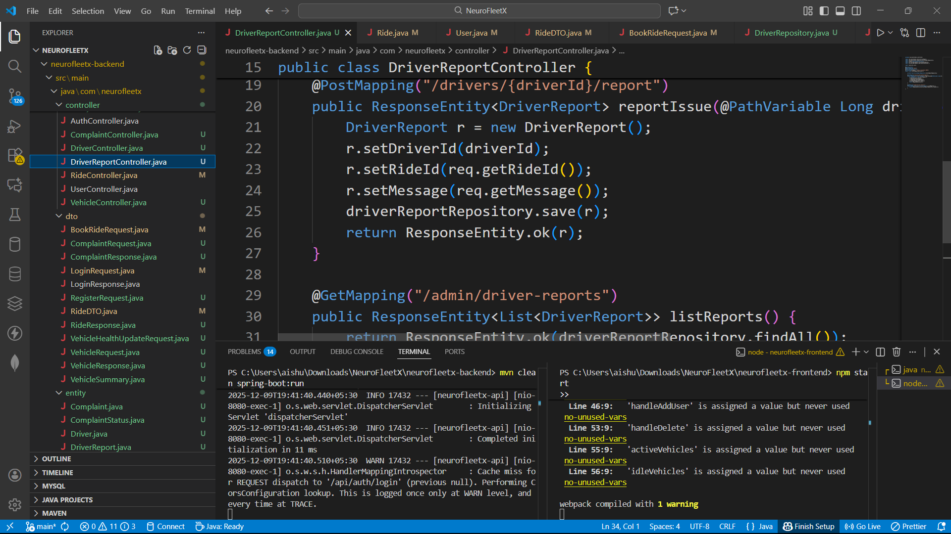 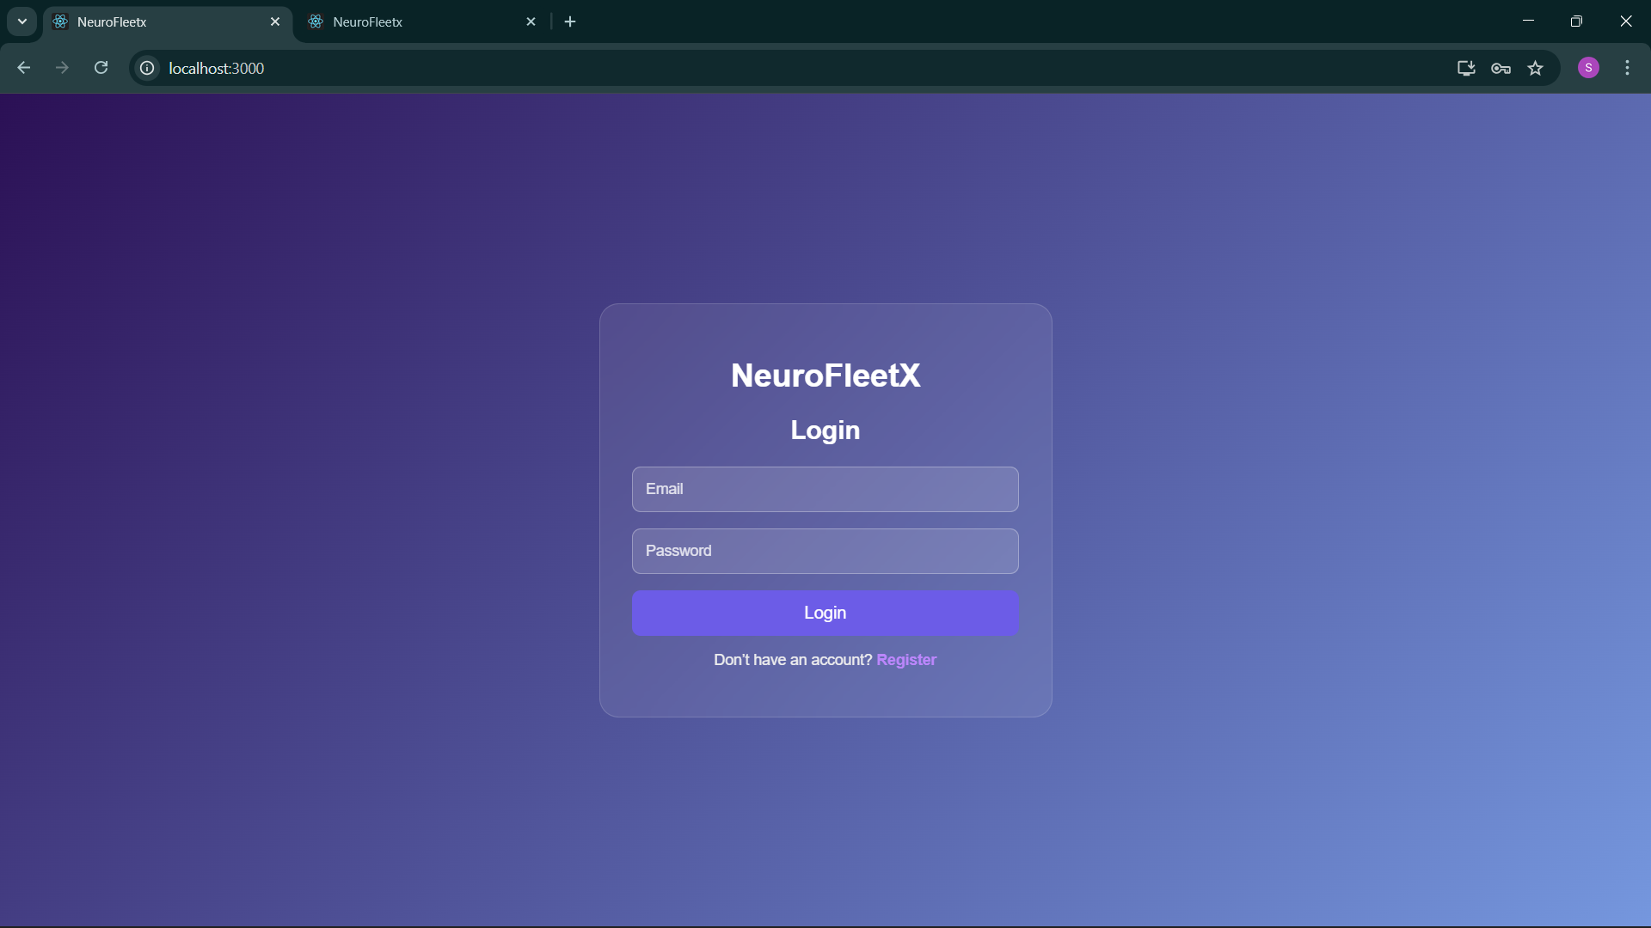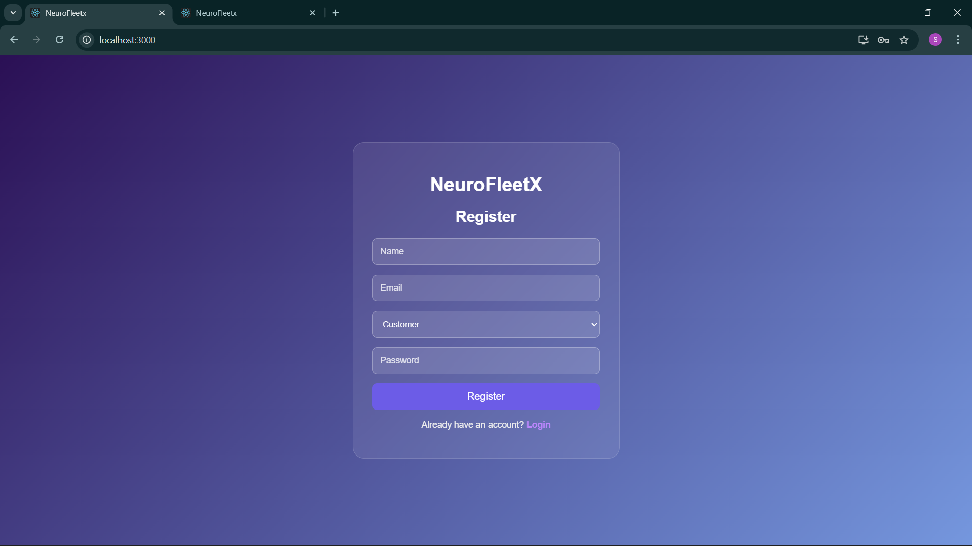

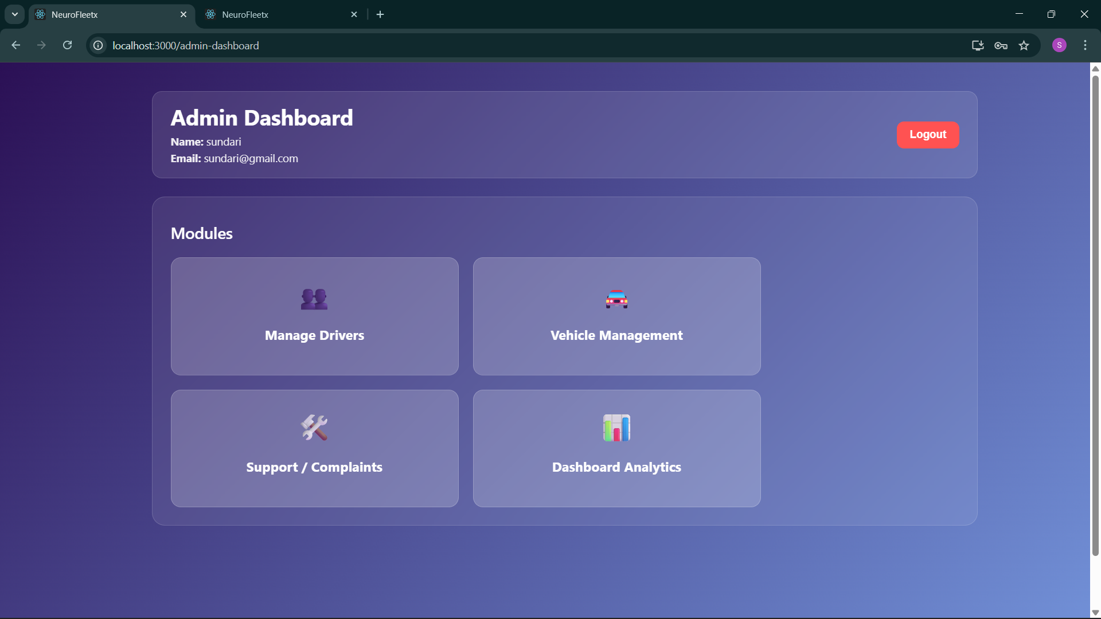

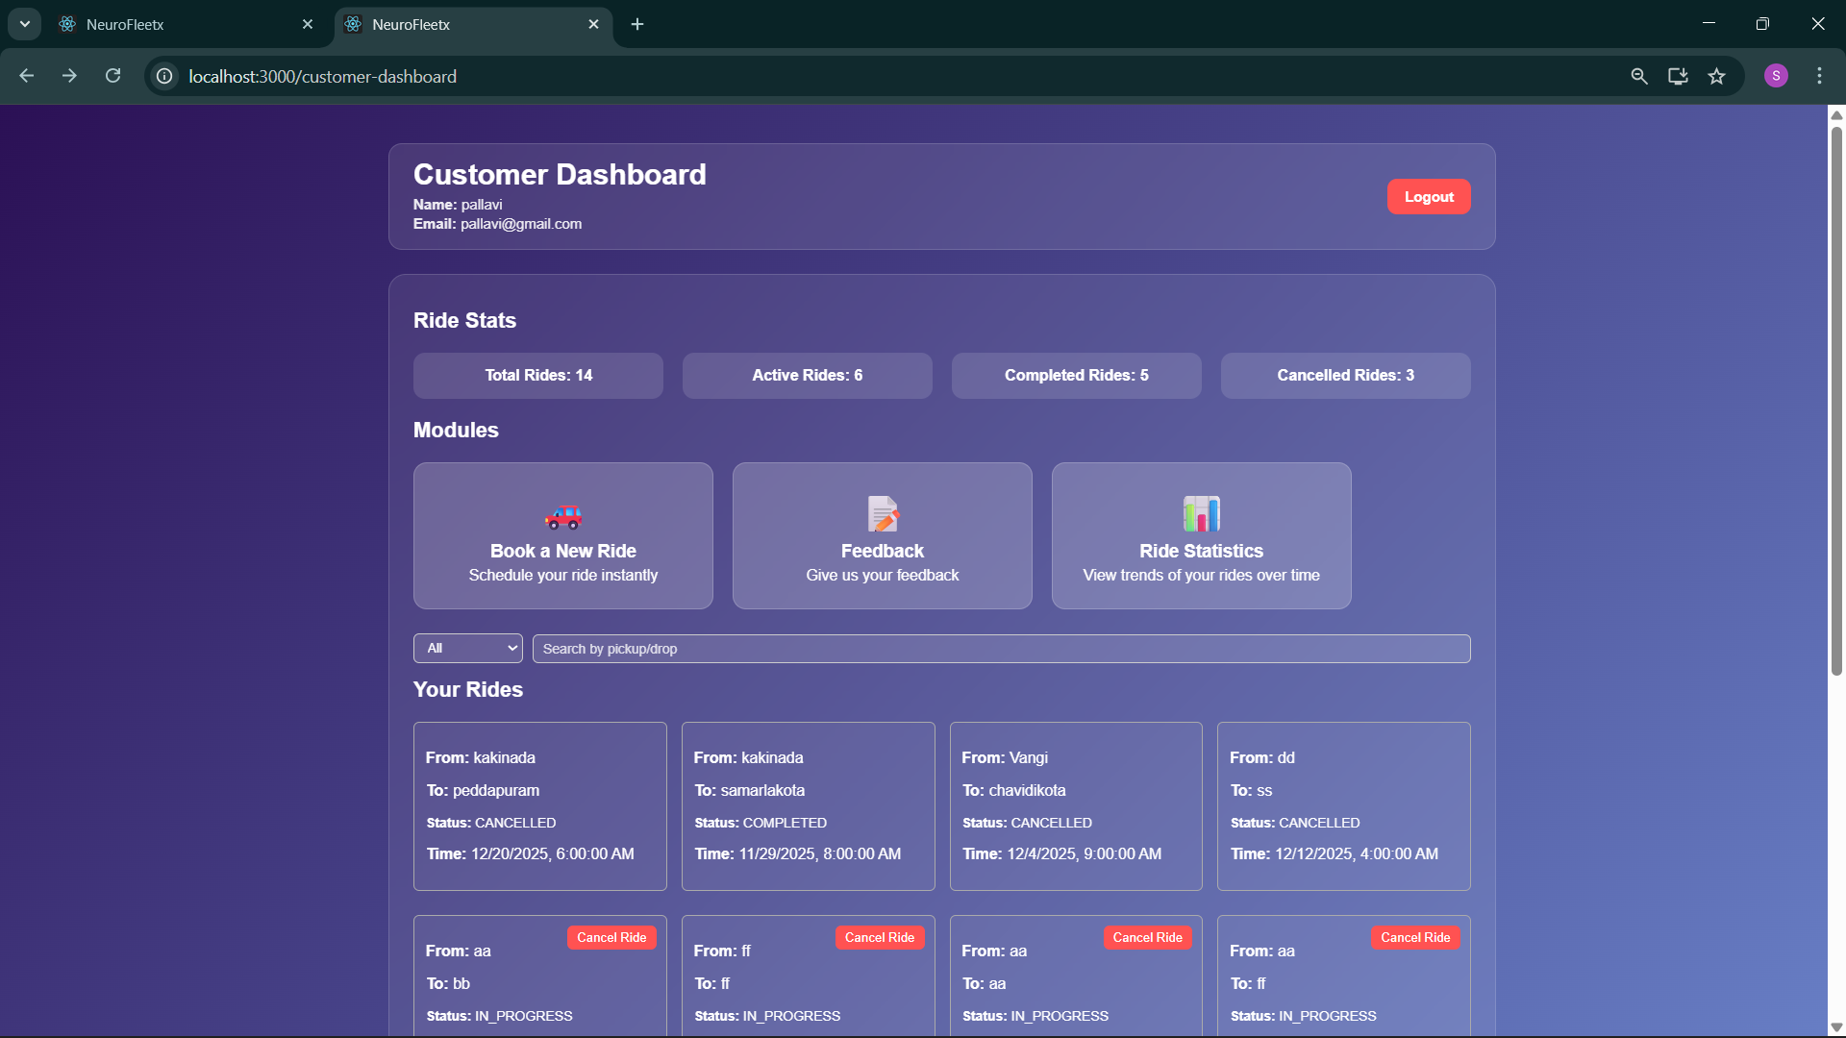

# 

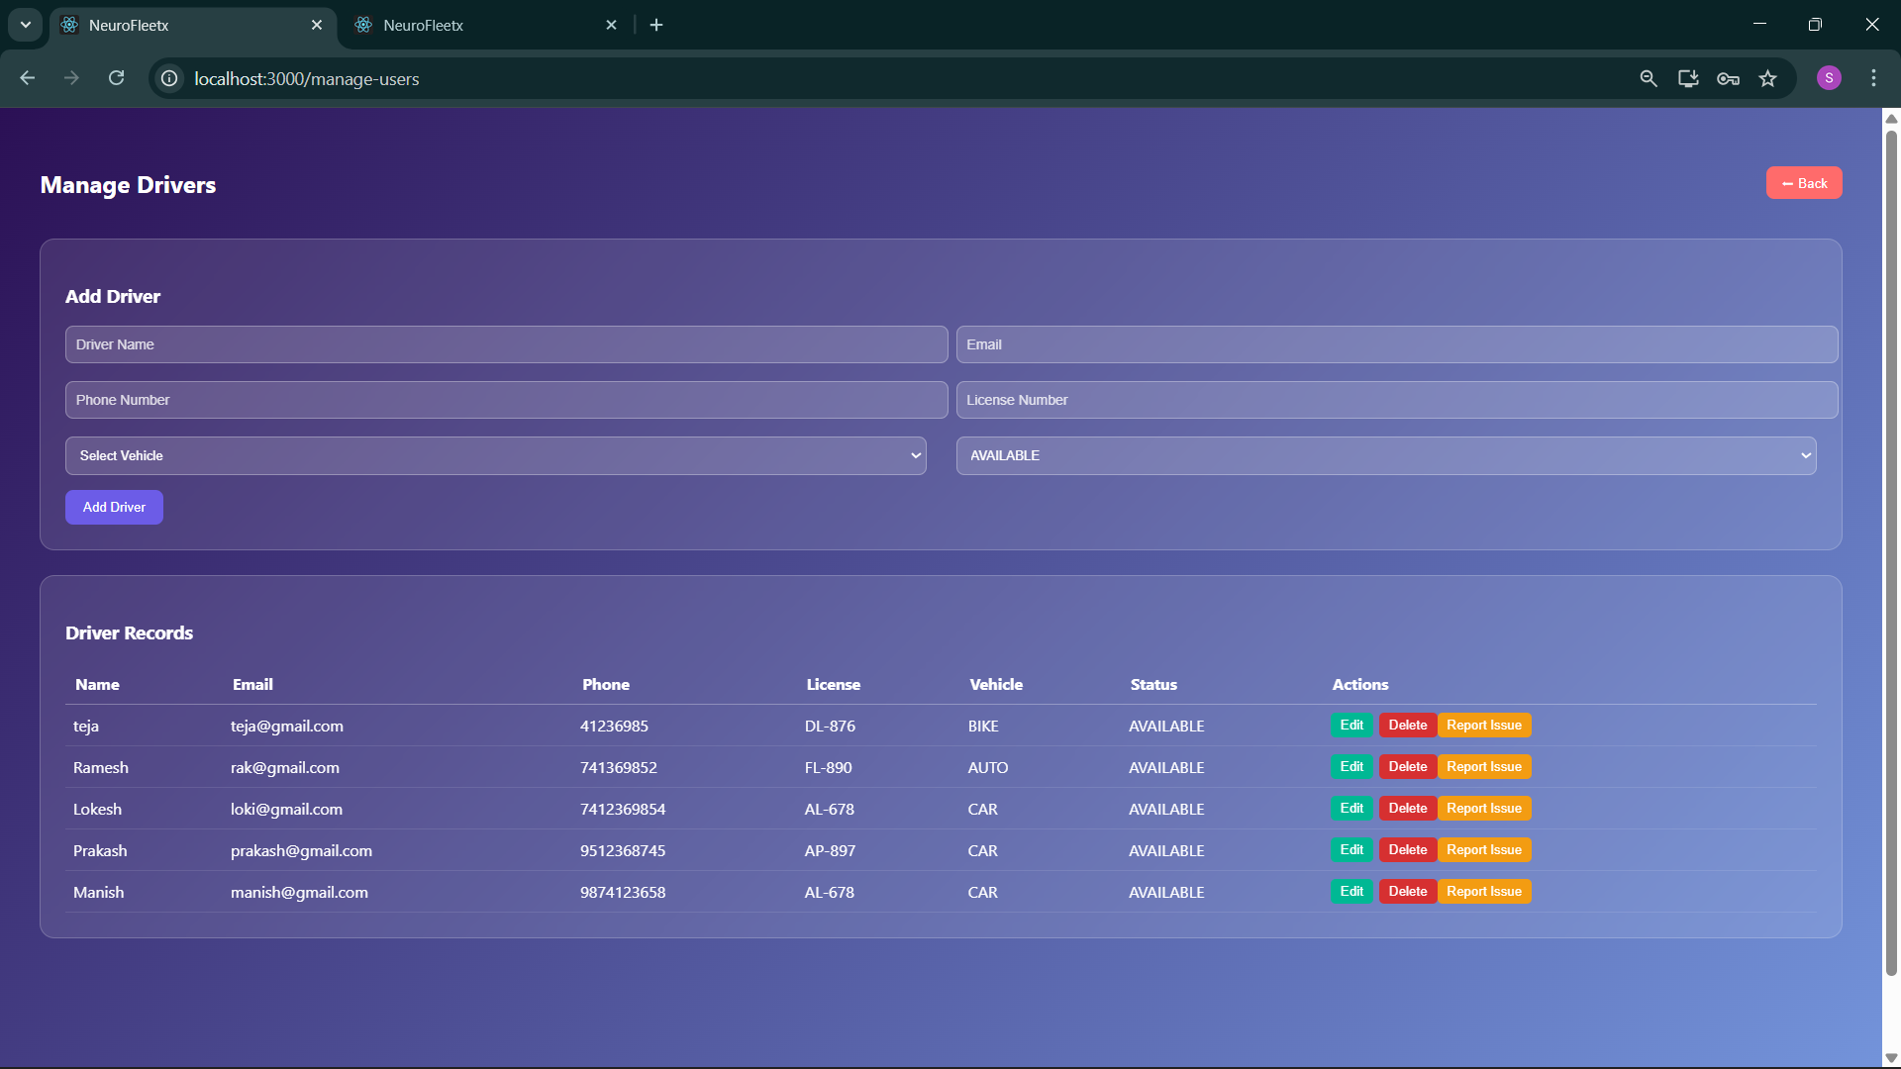

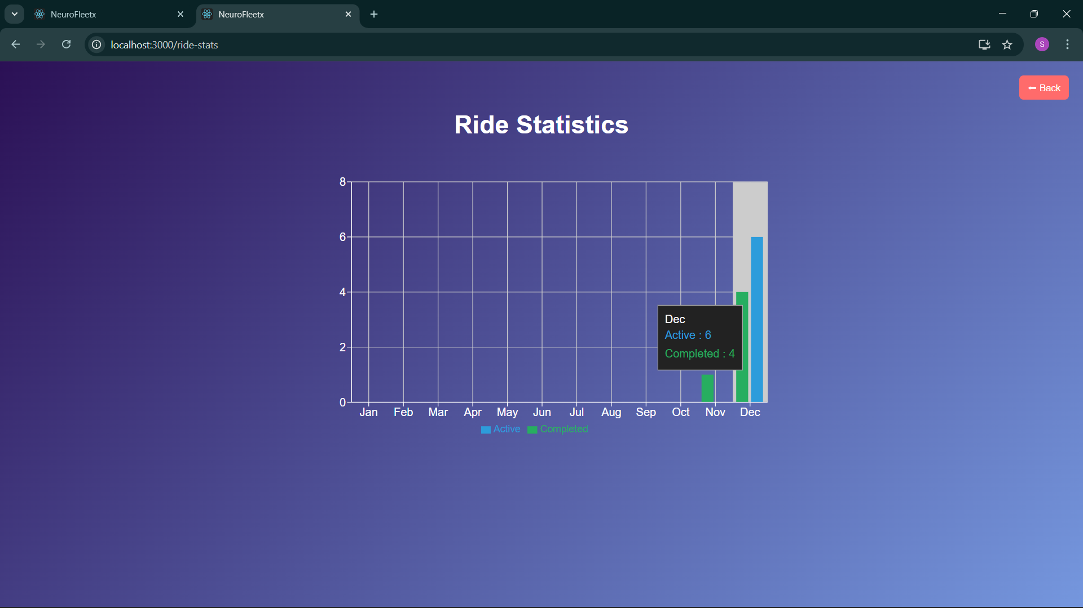

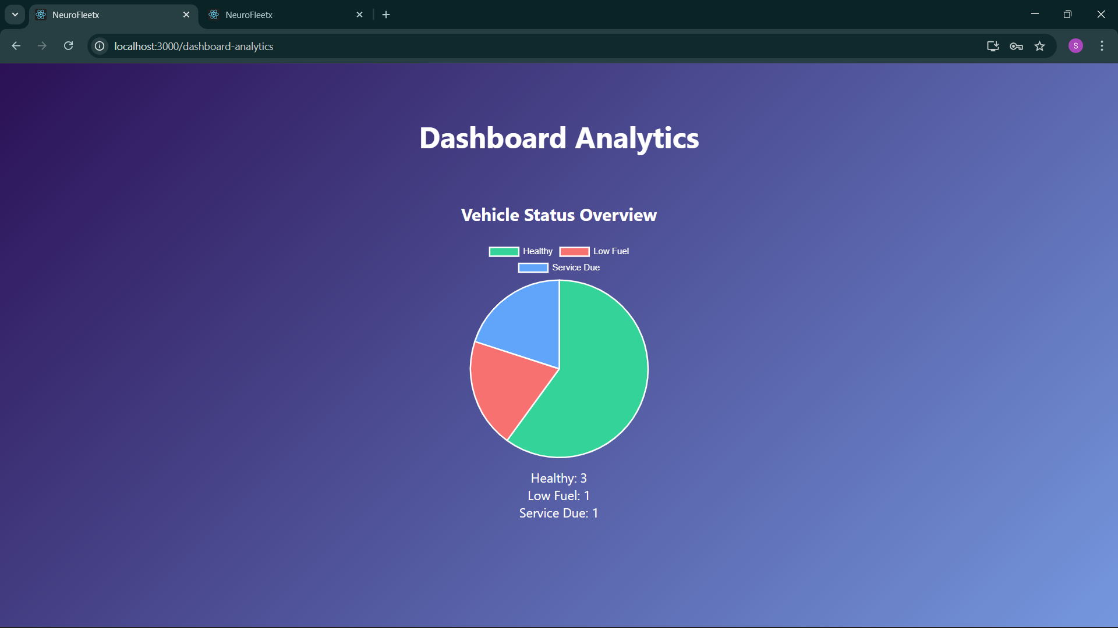

# 7. Challenges Faced Technical Challenges and Resolutions:

# Driver Assignment Logic: *Challenge:* Automatically assigning drivers based on availability and matching vehicle type was complex. *Resolution:* Implemented filtering of available drivers by vehicle type and assigned the first suitable driver. Added manual assignment as a fallback.

# Ride Status Management: *Challenge:* Updating rides from BOOKED → IN_PROGRESS → COMPLETED based on booking time required careful handling to avoid incorrect status changes. *Resolution:* Implemented a scheduler that checks ride timings every minute and updates ride status automatically.

# Database Relationships & Lazy Loading: *Challenge:* Handling Ride, Driver, and User relationships sometimes caused LazyInitializationException. *Resolution:* Used EAGER fetching for critical relations and explicitly loaded driver data in service methods.

**Operational Challenges and Resolutions:**

* **Data Consistency Across Dashboards:**

*Challenge:* Ensuring that updates in rides, vehicles, or drivers were reflected correctly in both customer and admin dashboards was difficult.  
*Resolution:* Implemented centralized service methods for all updates, reduced duplicate logic, and refreshed dashboard data through controlled API calls.

* **Coordinating Frontend–Backend Integration:**

*Challenge:* Connecting React components with Spring Boot APIs required proper synchronization of API contracts, leading to temporary mismatches in data formats and response structures.  
*Resolution:* Standardized all API request and response formats, documented endpoint behavior, and tested each module using Postman before integrating with the UI.

**Communication Challenges and Resolutions:**

* **Aligning Frontend and Backend Expectations:**

*Challenge:* Mismatched expectations occurred between what the frontend needed and what the backend returned (e.g., field names, response structure).  
*Resolution:* Maintained a shared reference for all API formats and updated it whenever changes were made, ensuring both sides stayed aligned.

* **Coordination Across Multiple Modules:**

*Challenge:* Managing communication for different modules (customer dashboard, admin dashboard, booking, analytics, complaints) sometimes caused confusion about priority tasks.  
*Resolution:* Followed a structured milestone plan and confirmed weekly targets with mentors, ensuring everyone remained aligned and aware of progress.

# 8. Learnings & Skills Acquired During this internship, I gained a strong combination of technical skills, practical development experience, and professional soft skills:

**Technical Skills:**

* Full-Stack Development: Built end-to-end modules using React for the frontend and Spring Boot for the backend.
* REST API Development: Learned how to design, implement, and integrate secure and scalable APIs.
* Database Management: Worked with MySQL, designed tables, and handled CRUD operations effectively.
* State Management & Routing: Used React hooks, context API, and protected routes for role-based access.
* Backend Architecture: Understood controller-service-repository patterns, exception handling, and schedulers.
* Authentication & Authorization: Implemented login, registration, token handling, and protected dashboards.
* UI/UX Implementation: Designed clean, functional dashboards for both customers and admins.
* Debugging & Problem-Solving: Improved ability to troubleshoot backend errors, API failures, and UI issues.

**Domain Knowledge:**

* Understood how vehicle booking systems, driver assignment, and ride tracking work in real-world mobility platforms.
* Learned workflows for user management, vehicle monitoring, complaints handling, and analytics dashboards.
* Gained exposure to how modern transport applications optimize operations and improve customer experience**.**

**Soft Skills:**

* Time Management: Planned weekly tasks and completed modules across four milestones efficiently.
* Communication Skills: Improved requirement clarification, documentation, and reporting progress professionally.
* Team Collaboration: Coordinated with mentors, aligned module expectations, and adapted based on feedback.
* Adaptability: Learned to quickly adjust to new features, resolve unexpected issues, and refine designs when required.

# 9. Testimonials from team During this internship, I gained hands-on experience working on a real-world software development project, which significantly boosted my technical confidence and problem-solving skills. I successfully contributed to multiple modules across the system and received positive feedback from my mentor for my consistency, quick learning, and ability to handle challenging tasks independently. This project helped me understand how professional development workflows operate, and I am proud of the progress I made in building functional features that added real value to the system.

# 10. Conclusion The NeuroFleetX internship was a highly valuable and transformative experience that allowed me to apply my technical knowledge in a real-world project. Developing a full-stack mobility management system strengthened my skills in React, Spring Boot, and database integration while giving me practical exposure to industry-level development workflows. The experience improved my problem-solving ability, enhanced my confidence in building complete software modules, and helped me understand how large-scale applications are designed, implemented, and optimized. This internship aligns perfectly with my academic and career goals, as it has strengthened my foundation in software development and prepared me for future opportunities in full-stack engineering and intelligent mobility solutions.

# 11. Acknowledgements

I would like to express my sincere gratitude to NeuroFleetX for giving me the opportunity to work on this internship project and gain valuable industry-level experience. I am especially thankful to my mentor, **Mr. Senthil**, for his continuous guidance, support, and constructive feedback throughout the project. His mentorship greatly helped me overcome challenges and improve the quality of my work. I also appreciate the assistance and cooperation of all team members who contributed to my learning during this journey.